LETSDEFEND LAB WRITEUP 06 / 06

Incident Response on Linux
  - Partial completion: restricted lab access documented with screenshot

Training context
This course introduces Linux incident response using account, process, service, filesystem, cron and SSH-key artefacts. The accessible reading lessons were studied; the restricted hands-on environment could not be examined directly.

Access issue and investigation
- Navigated to the “Users and Groups” training lesson.
- Located the Lab Environment → Connect option.
- Clicked Connect; the site displayed a Free versus VIP+ comparison and a $39.99/month subscription option.
- Preserved the popup screenshot and did not purchase access, consistent with the free-tools guideline.

Consequence and honest status
Lab-specific questions such as the compromised /etc/passwd account, suspicious web shell, reverse-shell IP and SSH authorized-keys user remain unverified. This writeup does not supply guessed answers or claim a fully completed practical lab.

Read-only checks that would be used with permitted access
cat /etc/passwd
find /var/www -type f -name "*.php"
systemctl list-unit-files --type=service
crontab -l
sudo find /home /root -name authorized_keys
These are investigation examples, not commands claimed to have been executed within the locked LetsDefend environment. The service name reverse.service previously appeared in a public walkthrough, but is not treated as a verified result from this ZIP.
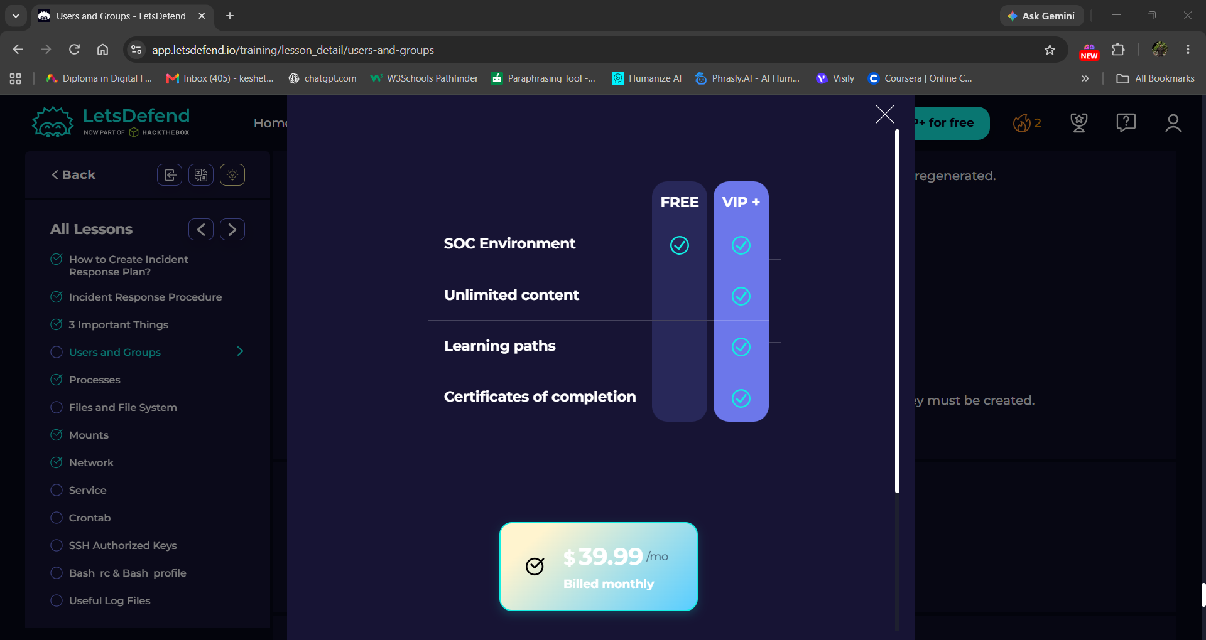
Evidence: VIP+ access comparison shown after attempting to connect to the lab
Status: PARTIAL – lesson content accessed; lab-dependent investigation not completed because VIP+ access was required.

